Additional Material on Multimedia

Exercise 1: Study the diagram of Mouse below and answer the following questions.
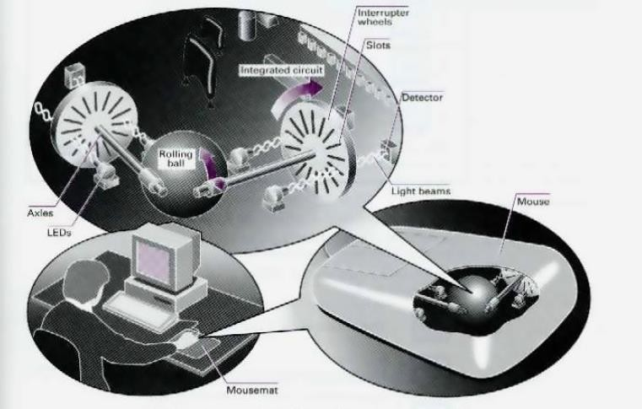

- Move the mouse to the left and the cursor moves to the left .
- The mouse contains a rolling balls.
- There are two axles inside the mouse and two interrupter wheels.
- When you move the mouse, the ball .
- The mouse moves over a mousemat . Now read this text to check your answer.
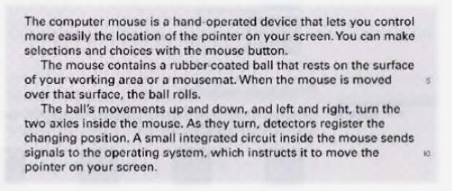

Exercise 2: Study the information about the keys on the keyboard. Then look at the statements (1-7) and correct the ones which are wrong.
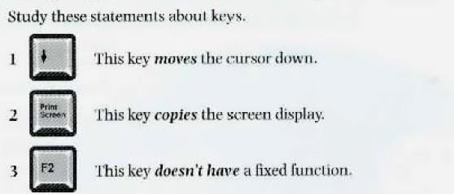

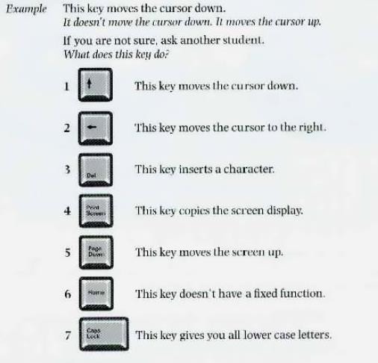

Exercise 3: With the help of the table, write a brief description of a keyboard. Look at the example below.
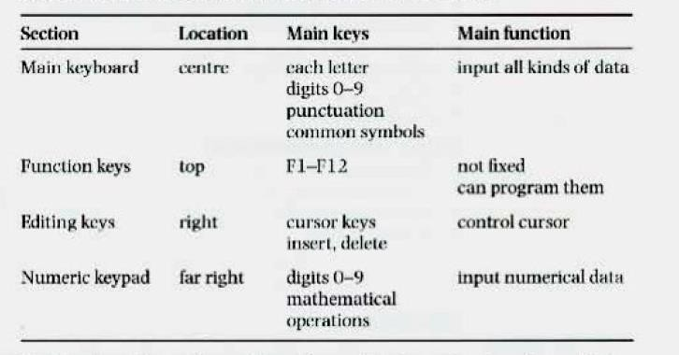

Most keyboards have four sections. The main keyboard has keys for each letter and the digits 0 to 9. It also has keys for punctuation and other common symbols. It is used for inputting all kinds of data.

.

.

.

